INTRODUCTION

ABSTRACT:

Visual Basic is an interesting topic, which has different types. It has all
The methods have their won features with each having merits and demerits which
Help in data processing. The topic includes their architecture representing the
Elements involved in it and their action is also specified.

Visual Basic 6.0 allows creating object-oriented applications. Visual Basic 6.0 profoundly concentrates on the Internet development features, Active X technology, enhanced controls, enhanced features of existing control, client/server, new language features development, data access, a few design enhancement etc.,

SYSTEM ENVIRONMENT

Following are the technical resources required for developing the system.

HARDWARE REQUIREMENTS: -
- PC 586 Dx & above with 4.1 G.B hard disk.
- RAM capacity of minimum of 32 MB
- Floppy disk drive either 1.2 MB or 1.44 MB
- Floppy 1.2 MB or 1.44 MB
- Epson stylus COLOR 480

SOFTWARE REQUIREMENTS: -
- WINDOWS 95/98 ENVIRONMENT
- MS - ACCESS(BACK END)
- VISUAL BASIC 6.0(FRONT END)

OTHER REQUIREMENTS: -
- U.P.S
- Stationary
- Miscellaneous assets.

SECURITY: -
Security measures present unauthorized to access the system. Any system to have a security measure should is provided with login-id and password facility. Security is provided for both the database level and application level. Only the authorized persons can avoid the data corruption to accessed database. The database can accessed only of correct login-id and password is provided.

SOFTWARE CONFIGARATION

GUI : VISUAL BASIC 6.0

OPERATING SYSTEM : WINDOWS 98

BACK END : MS - ACCESS

HARDWARE CONFIGARATION

- An IBM personal computer or a close preferably Pentium 233 MHz.
- An SVGA or better Display System.
- 32 MB of variable memory.
- 256 KB of external Cache Memory.
- A 3.5” 1.44 MB Floppy Disk Drive.
- A 4.3 GB Hard Disk.
- An Inkjet or Dot Matrix Printer.
- A Microsoft mouse or a compatible pointing device.

About Visual Basic Language: -

Visual Basic was developed forms the BASIC programming language. In 1970’s Microsoft got its start by developing ROM based interpreted Basic for the early microprocessor based computer. In 1982, Microsoft QuickBasic revolutionized Basic and legitimized as a serious development language for MS-DOS environment. Later on, Microsoft Corporation created the enhanced version of BASIC called Visual Basic for Windows.

Visual Basic 6.0: -

Visual Basic 6.0 allows creating Object Oriented Application. When Visual Basic originally developed, it allowed to the programmer to create programs using pre-defined objects, forms and controls. It uses some of the Windows 95 Controls. Visual Basic 6.0 can be used to develop both standalone systems and Client Server Based systems.

Visual Basic 6.0 comes in three categories

- Standard Edition
- Professional Edition
- Enterprise Edition

Features of Visual Basic 6.0: -

Visual Basic 6.0 profoundly concentrates on the Internet development features, ActiveX technology, enhanced controls, enhanced features of existing control, client/server, new language features development, data access, a few design enhancement etc.,

Native Code: -

A Visual Basic project is compiled to native code for faster execution. Profiles native code using new native code compiler option, and debug native code using the Visual C++ environment.

Create Active X Controls: -

Features of existing controls can be combined, or new control can be created form the scratch. ActiveX controls created with Visual Basic have events, data binding
Support, licensing support, property pages, Internet features, and more.

Wizards: -

The application Wizard is new and the Setup Wizard has been enhanced to enable creating a dependency file for a standard project. In the professional Edition, the Active X control Interface Wizard, Active X Document Migration Wizard, Data Form Wizard, and property page Wizard is new. The Setup Wizard has been enhanced to support distribution via the Internet. The installation of remote server components using Distributed COM (DCOM) and Remote Automation is an added feature. The ability to create dependency files for projects and components created with Visual Basic.

Extensibility Model: -

The new model allows to programmatically extending the development environment and control projects, events, code, and Visual elements.

Declare, Raise, and Handle Events: -

Objects provided by the components can raise events that can be handled in other applications, or by our objects, using with Events variables, Events provide a simple alternative to asynchronous callbacks.

Multithreaded DLLs: -

DLL components marked for unattended execution can be used efficiently by multithreading applications such as Internet Browser.

Internet Transfer Control: -

This control provides HTTP and FTP support.

Multiple Project: -

Multiple projects can be opened in the same instance of Visual Basic, with is useful for debugging Active X controls.

Create Active X Document: -

ActiveX document s can be created that boosts the Visual Basic application to the Internet Browser Windows. The data control, DAO or Microsoft Access, you can create that is virtually database independent, because jet automatically performs all syntax and data manipulation translations.

ODBC Direct: -

This feature allows us to access ODBC data sources throughout the RDO with DAO objects, by passing the Microsoft Jet Database Engine. We can also use ODBC Direct through the data Control, by binding controls to data and setting and ODBC Direct property.

Dock able and Linkable Windows, Toolbox, and Toolbars: -

Project, properties, Debugging, and Object Browser windows can be docked in the development environment and/or linked to each other. Toolbars can be docked, undocked, or linked to each other.

Automation: -
A technology that enables application to provide objects in a consistent way to other application, development tools and macro languages. Formerly known as OLE Automation.

Class: -
Class is the formal definition of an object. The class acts as template which an instance of an object is created at run time. The class defines the properties of the object and the methods used to control the object’s behavior. Class’s uses can typically be categorized as one of three general types. They are
- Creation of Business Objects
Ex: Employee object
- Encapsulation of programming functions
Ex: Encapsulate the code that opens a record set in a class module
- Visual Basic Add-Ins
Ex: Program Wizard

Polymorphism: -

Polymorphism relates to the use of the same method name in various objects; for example, a print method for the printer, a form, or a picture box. While the name of the method is the same, the actual code for the method in each object can be different. However, because the code for the method is encapsulated in the object, each object knows how to perform the correct task when the method is called, this feature allows classes to support multiple interfaces. Users of components can early bind to these interfaces, regardless of the object that implements them.

Encapsulation: -

The data about an object and the code used to manipulate the data are contained within the object itself. The data is stored as the properties of the object and the code as the methods of the object. This feature allows the object data and code to stand alone, independent of outside routines.

The Component Object Model (COM): -

The Component Object Model (COM) is a specification. It specifies how to build components that can be dynamically interchanged. Com provides the standard that component and clients follow to ensure that can operate together.

COM is Microsoft’s top-level, all encompassing binary and wire specification for the interoperation of one app with another, across multiple applications, machines, and hardware types. It provides the following features.

- Single programming model
- Binary compatibility
- Uniform data transfer
- Structured storage
- Component software, reusable functionality
- Macro programmability
- Programming language independent
- Distributed operation

Advantages of Using COM: -

- Binary Compatibility and Cross-platform Development
- Code Reusability
- Version Control

Binary Compatibility and Cross-platform Development: -

The first major advantage of component technology binary compatibility and cross-platforms. Since becoming an Industry-wide standard, COM-compliant client applications and servers are independent of the development language and operating system.

Code Reusability: -

The second major advantage of component technology is an enhancement of DLL technology. COM components expose groups of methods, known as interfaces, through which clients interact with objects. Because these interfaces are documented, many clients for a variety of different purposes can reuse the code that creates those objects.

Version Control: -

The last major advantage resolves issues related to version control. COM components are said to be self-versioning. This means that new functionality can be added to a component without affecting clients that already use the components. Functionality is not lost when components are upgraded it is always enhanced or added.

MS-ACCESS:

When we create a Microsoft Access database, we create one file that contains the data and table structures as well as the queries, forms, reports and other objects that make up the database.

Protecting information can be an important part of developing a Microsoft Access database. By securing your database, you can control what a user, is a group of users, can do with database objects. Microsoft Access security made up of several pieces that must be in place before security is complete. Security relies on a relationship between Microsoft Access stores account information with the work group and permissions assignment in the database (.mdb) file Microsoft Access Version 7 system database includes several internal security enhancements.

Encrypting a database makes it indecipherable by a utility program or word processor. Encrypting a database compacts the database file and makes it indecipherable by a utility program or word processor. Decrypting a database reverses it indecipherable in order to protect it from unauthorized viewing or use.

SYSTEM ANALYSIS

SYSTEM DECRIPTION:

The proposed system is for making easier to manage subscriber details, post details, money order details, bills. So this will be developed for helping the post office administrative the above things. The overall system is control through the main menu.

The main money contains 6 parts.

- Sales details.
- Register post.
- Speed post.
- Money order.
- Money savings.
- Reports.

SALES DETAILS:-

This form contains the various types of postcards, stamps which are to sold.

- Postcards:- The various types of postcards are like envelop, competition postcard, printed cards, etc are their amount.

- Stamps:- The different stamp cost of 1 to 50 are sold.

- Register post:- the register form contains the postage where to be delivered it contains.

Sender address
Receiver address
Acknowledgement
Weigtage
Commission

- Speed post:- As form of register posts the same will be in the speed post also. The extra amount will be taken for urgently.
- money order:- money order form contains details of person to whom money is to be sending, and the sender address.
- money savings:- the savings form we have the details on various types of savings like short term or long term savings.

EXISTING SYSTEM:

The present system of Postal service does not contain the courier transactions and maintain the details of all other transactions such as maintaining money order details speed post transactions register post transaction saving and recurring bank transactions all these are carried out manually. This postal system is made into atomization in order to render services more quickly and efficiently to the people.

SYSTEM DESIGN

DATA FLOW DIAGRAMS:

Sales form1.0

Register post 2.0

Money order 3.0

USER

USER

Money savings 4.0

Reports 5.0

SALES FORM:

Stamp details 1.1
Stamps

USER

Postcard details 1.2
Postcards

REGISTER POST:

Sender details 2.1
Receiver details 2.2
Wattages 2.3
Commission 2.4
USER
Sender
Receiver
weight age
Commission

MONEY OREDR:

Sender details 3.1
sender

Receiver details 3.2
Amount details 3.3
USER
Receive
Amount

MONEY SAVINGS:

Receiving details 4.1
Fixed deposit 4.2
USER
Receiving
Fixed deposit

DATABASE DESIGN:

SPEED POST:

DATA NAME | DATA TYPE | SIZE
SNO | DOUBLE | 8
DATE | DATE | 8
NAME | TEXT | 20
AREA | TEXT | 20
CITY | TEXT | 20
COUNTRY | TEXT | 20
PINCODE | DOUBLE INTEGER | 8
DISTRICT | DOUBLE | 8
PREPAID | CURRENCY | 8
WEIGHT | INTEGER | 2
POSTAGE | CURRENCY | 8
FEE | CURRENCY | 8
ACKDUE | CURRENCY | 8
TOTAL AMT | CURRENCY | 8
NETAMT | CURRENCY | 8
COUNT | INTEGR | 2

SALES:

DATA NAME | DATA TYPE | SIZE
SNO | DOUBLE | 8
DATE | DATE | 8
STAMPS | TEXT | 20
SREQNO | INTEGER | 2
POSTCARD | TEXT | 20
PRATE | CURRENCY | 8
PREQNO | INTEGER | 2
AMT | CURRENCY | 8
COUNT | INTEGER | 2

MONEY SAVINGS:

DATA NAME | DATA TYPE | SIZE
SNO | DOUBLE | 8
ACCNO | DOUBLE | 8
NAME | TEXT | 20
AREA | TEXT | 20
CITY | TEXT | 20
COUNTRY | TEXT | 20
PINCODE | DOUBLE | 8
SCHTYPE | TEXT | 20
INTR RATE | CURRENCY | 8
DEPDATE | DATE | 8
DEPAMT | CURRENCY | 8
TOTAMT | CURRENCY | 8
COUNT | INTEGER | 2

REGISTER POST:

DATA NAME | DATA TYPE | SIZE
SNO | DOUBLE | 8
SDATE | DATE | 8
NAME | TEXT | 20
AREA | TEXT | 20
CITY | TEXT | 20
COUNTRY | TEXT | 20
PINCODE | DOUBLE | 8
PREPAID | CURRENCY | 8
WEIGHT | INTEGER | 2
POSTAGE | CURRENCY | 8
REGFEE | CURRENCY | 8
ACKDUE | CURRENCY | 8
TOTAMT | CURRENCY | 8
NETAMT | CURRENCY | 8
COUNT | INTEGER | 2

SYSTEM IMPLEMENTATION:

FORM DESCRIPTION:

The proposed system is for making easier to manage subscriber details, post details, money order details, bills. So this will be developed for helping the post office administrative the above things. The overall system is control through the main menu.

The main money contains 6 parts.

- Sales details.
- Register post.
- Speed post.
- Money order.
- Money savings.
- Reports.

SALES DETAILS:-

This form contains the various types of postcards, stamps which are to sold.

Postcards:- The various types of postcards are like envelop, competition postcard, printed cards, etc are their amount.

Stamps:- The different stamp cost of 1 to 50 are sold.

Register post:- the register form contains the postage where to be delivered it contains.

Sender address
Receiver address
Acknowledgement
Weigtage
Commission

Speed post:- As form of register posts the same will be in the speed post also. The extra amount will be taken for urgently.
Money order:- money order form contains details of person to whom money is to be sending, and the sender address.
Money savings:- the savings form we have the details on various types of savings like short term or long term.

SCREENS:

REGISTER POST:

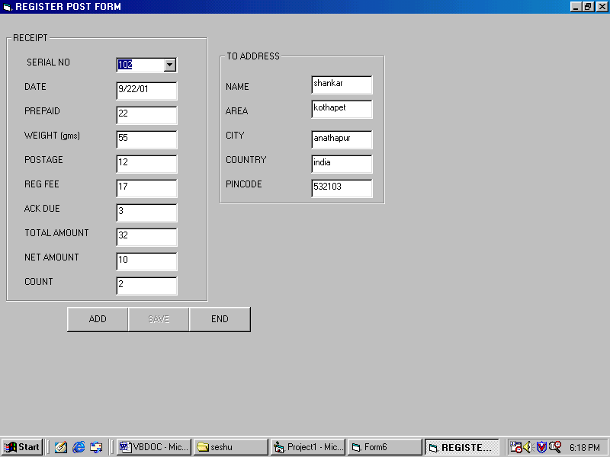

SPEED POST:

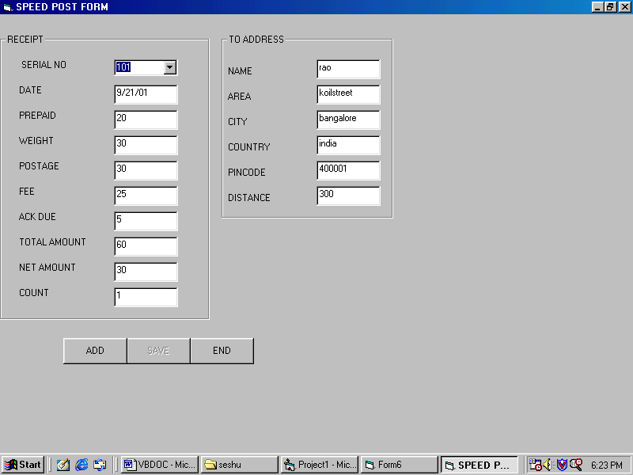

MONEY ORDER :

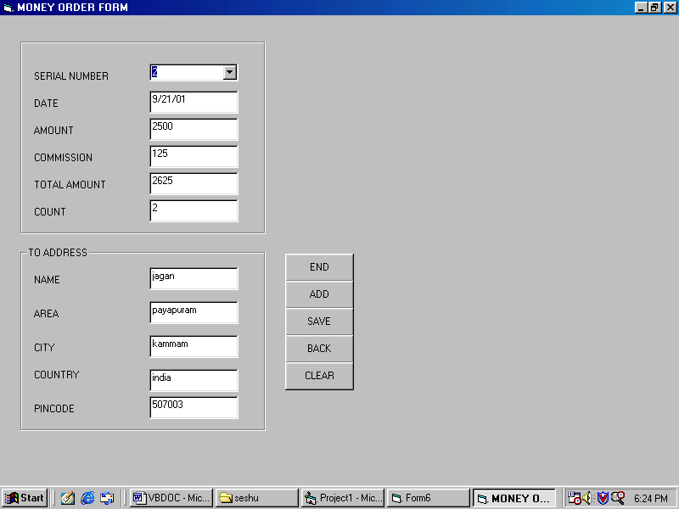

SALES:

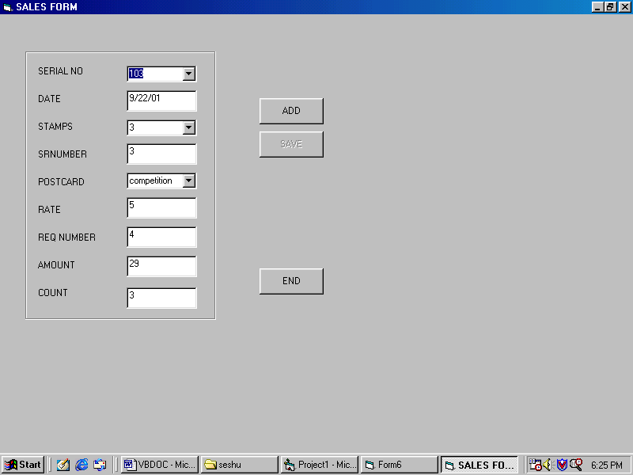

MONEY SAVINGS:

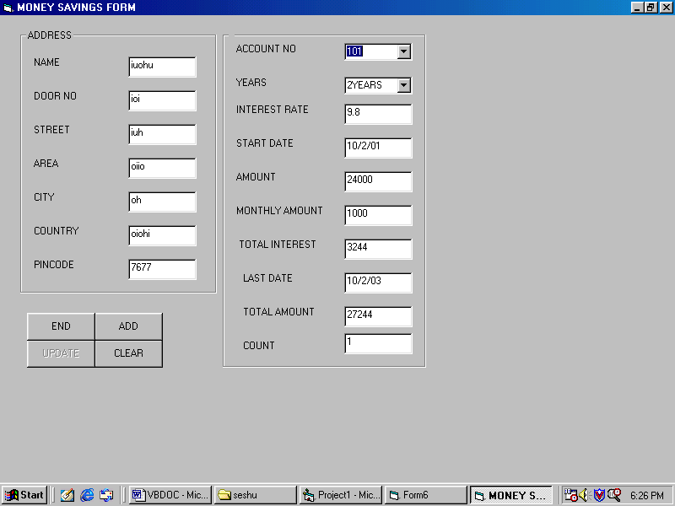

SOURCE CODE

************************ MONEY ORDER ******************
Option Explicit
Dim db As Database
Dim rs, rs1 As Recordset
Dim a, k As Integer

Private Sub Combo1_Click()
rs.MoveFirst
While Not rs.EOF
If Combo1.Text = rs(0) Then
Call data
End If
rs.MoveNext
Wend
End Sub

Private Sub Command5_Click()
Call save
rs.MoveLast
Combo1.AddItem rs(0)
MsgBox "record saved"
Call clear
End Sub

Private Sub Command4_Click()
rs.MoveLast
a = rs(0)
Call clear
Combo1.Text = a + 1
Text1.Text = Date
Text2.SetFocus
Command5.Enabled = True
End Sub

Private Sub Command3_Click()

Form6.Show
End Sub

Private Sub Command6_Click()
Form6.Show
Load Form6
End Sub

Private Sub Command7_Click()
Call clear
End Sub

Private Sub Form_Load()
Set db = OpenDatabase("C:\MY DOCUMENTS\SESHU\POSTOFF.MDB")
Set rs = db.OpenRecordset("moneyorder")
rs.MoveFirst
While Not rs.EOF
Combo1.AddItem rs(0)
rs.MoveNext
Wend
End Sub

Private Sub Text7_lostfocus()
Dim l, i, J As Integer
If ((Text5.Text = "india" Or Text5.Text = "INDIA") And Text7.Text <= 5000) Then
l = 5
J = 1
For i = 1 To Val(Text7.Text)
Text8.Text = l
J = J + 1
i = J * 100
l = l + 5
Next
Text9.Text = Val(Text7.Text) + Val(Text8.Text)
ElseIf ((Text5.Text = "india" Or Text5.Text = "INDIA") And Text7.Text > 5000) Then
MsgBox "AMOUNT SHOULD BE <5000"
Text7.Text = ""
Text7.SetFocus
ElseIf ((Text5.Text <> "india" Or Text5.Text <> "INDIA") And Text7.Text <= 50000) Then
l = 15
J = 1
For i = 1 To Val(Text7.Text)
Text8.Text = l
J = J + 1
i = J * 100
l = l + 15
Next
Text9.Text = Val(Text7.Text) + Val(Text8.Text)
ElseIf ((Text5.Text <> "india" Or Text5.Text <> "INDIA") And Text7.Text > 50000) Then
MsgBox "AMOUNT SHOULD BE <50000"
Text7.Text = ""
Text7.SetFocus
End If
rs.MoveLast
If Text1.Text = rs(1) Then
k = rs(10)
Text10.Text = k + 1
Else
Text10.Text = 1
End If
End Sub

Public Sub clear()
Combo1.Text = ""
Text1.Text = ""
Text2.Text = ""
Text3.Text = ""
Text4.Text = ""
Text5.Text = ""
Text6.Text = ""
Text7.Text = ""
Text8.Text = ""
Text9.Text = ""
Text10.Text = ""
End Sub

Public Sub save()
rs.AddNew
rs(0) = Combo1.Text
rs(1) = Text1.Text
rs(2) = Text2.Text
rs(3) = Text3.Text
rs(4) = Text4.Text
rs(5) = Text5.Text
rs(6) = Text6.Text
rs(7) = Text7.Text
rs(8) = Text8.Text
rs(9) = Text9.Text
rs(10) = Text10.Text
rs.Update
End Sub

Public Sub data()
Combo1.Text = rs(0)
Text1.Text = rs(1)
Text2.Text = rs(2)
Text3.Text = rs(3)
Text4.Text = rs(4)
Text5.Text = rs(5)
Text6.Text = rs(6)
Text7.Text = rs(7)
Text8.Text = rs(8)
Text9.Text = rs(9)
Text10.Text = rs(10)
End Sub

**********************REGISTER POST *******************

Option Explicit
Dim db As Database
Dim rs As Recordset
Dim a As Integer

Private Sub Combo1_Click()
rs.MoveFirst
While Not rs.EOF
If Combo1.Text = rs(0) Then
Text1.Text = rs(1)
Text2.Text = rs(2)
Text3.Text = rs(3)
Text4.Text = rs(4)
Text5.Text = rs(5)
Text6.Text = rs(6)
Text7.Text = rs(7)
Text8.Text = rs(8)
Text9.Text = rs(9)
Text10.Text = rs(10)
Text11.Text = rs(11)
Text12.Text = rs(12)
Text13.Text = rs(13)
Text14.Text = rs(14)
End If
rs.MoveNext
Wend
End Sub

Private Sub Command2_Click()
rs.AddNew
rs(0) = Combo1.Text
rs(1) = Text1.Text
rs(2) = Text2.Text
rs(3) = Text3.Text
rs(4) = Text4.Text
rs(5) = Text5.Text
rs(6) = Text6.Text
rs(7) = Text7.Text
rs(8) = Text8.Text
rs(9) = Text9.Text
rs(10) = Text10.Text
rs(11) = Text11.Text
rs(12) = Text12.Text
rs(13) = Text13.Text
rs(14) = Text14.Text
rs.Update
rs.MoveLast
Combo1.AddItem rs(0)
MsgBox "record saved"
End Sub

Private Sub Command1_Click()
If Not rs.BOF Then
rs.MoveLast
a = rs(0)
Combo1.Text = a + 1
Text2.Text = ""
Text3.Text = ""
Text4.Text = ""
Text5.Text = ""
Text6.Text = ""
Text7.Text = ""
Text8.Text = ""
Text9.Text = ""
Text10.Text = ""
Text11.Text = ""
Text12.Text = ""
Text13.Text = ""
Text14.Text = ""
Else
Combo1.Text = 101
End If
Text1.Text = Date
Text2.SetFocus
Command2.Enabled = True
End Sub

Private Sub Command3_Click()
Unload Me
Form6.Show
End Sub

Private Sub Form_Load()
Set db = OpenDatabase("C:\MY DOCUMENTS\SESHU\POSTOFF.MDB")
Set rs = db.OpenRecordset("registerpost")
If rs.BOF Then
MsgBox "no record exists"
Else
rs.MoveFirst
While Not rs.EOF
Combo1.AddItem rs(0)
rs.MoveNext
Wend
End If
Command2.Enabled = False
Command4.Visible = False
'Command5.Visible = False
End Sub

Private Sub Text8_lostfocus()
Dim k, l As Integer
If Text5.Text = "india" Then
a = 4
Else: a = 15
End If
If Val(Text8.Text) <= 20 Then
Text9.Text = a
ElseIf Val(Text8.Text) <= 40 Then
Text9.Text = 2 * a
ElseIf Val(Text8.Text) <= 60 Then
Text9.Text = 3 * a
ElseIf Val(Text8.Text) <= 80 Then
Text9.Text = 4 * a
ElseIf Val(Text8.Text) <= 100 Then
Text9.Text = 5 * a
Else: MsgBox "weight exceeded "
End If
Text10.Text = 17
Text11.Text = 3
Text12.Text = Val(Text9.Text) + Val(Text10.Text) + Val(Text11.Text)
Text13.Text = Val(Text12.Text) - Val(Text7.Text)
rs.MoveLast
If Text1.Text = rs(1) Then
k = rs(10)
Text10.Text = k + 1
Else
Text10.Text = 1
End If
rs.MoveLast
If Text1.Text = rs(1) Then
l = rs(14)
Text14.Text = l + 1
Else
Text14.Text = 1
End If
End Sub

********************* SPEED POST *********************
Option Explicit
Dim db As Database
Dim rs As Recordset
Dim a As Integer
Private Sub Combo1_Click()
rs.MoveFirst
While Not rs.EOF
If Combo1.Text = rs(0) Then
Text1.Text = rs(1)
Text2.Text = rs(2)
Text3.Text = rs(3)
Text4.Text = rs(4)
Text5.Text = rs(5)
Text6.Text = rs(6)
Text7.Text = rs(7)
Text8.Text = rs(8)
Text9.Text = rs(9)
Text10.Text = rs(10)
Text11.Text = rs(11)
Text12.Text = rs(12)
Text13.Text = rs(13)
Text14.Text = rs(14)
Text15.Text = rs(15)
End If
rs.MoveNext
Wend
End Sub
Private Sub Command2_Click()
rs.AddNew
rs(0) = Combo1.Text
rs(1) = Text1.Text
rs(2) = Text2.Text
rs(3) = Text3.Text
rs(4) = Text4.Text
rs(5) = Text5.Text
rs(6) = Text6.Text
rs(7) = Text7.Text
rs(8) = Text8.Text
rs(9) = Text9.Text
rs(10) = Text10.Text
rs(11) = Text11.Text
rs(12) = Text12.Text
rs(13) = Text13.Text
rs(14) = Text14.Text
rs(15) = Text15.Text
rs.Update
rs.MoveLast
Combo1.AddItem rs(0)
MsgBox "record saved"
Command2.Enabled = False
End Sub
Private Sub Command1_Click()
If Not rs.BOF Then
rs.MoveLast
a = rs(0)
Combo1.Text = a + 1
Text1.Text = Date
Text2.Text = ""
Text3.Text = ""
Text4.Text = ""
Text5.Text = ""
Text6.Text = ""
Text7.Text = ""
Text8.Text = ""
Text9.Text = ""
Text10.Text = ""
Text11.Text = ""
Text12.Text = ""
Text13.Text = ""
Text14.Text = ""
Text15.Text = ""
Else
Combo1.Text = 101
Text2.SetFocus
End If
Command2.Enabled = True
End Sub
Private Sub Command3_Click()
Unload Me
Form6.Show
End Sub
Private Sub Form_Load()
Set db = OpenDatabase("C:\MY DOCUMENTS\SESHU\POSTOFF.MDB")
Set rs = db.OpenRecordset("speedpost")
If rs.BOF Then
MsgBox "no record exists"
Else
rs.MoveFirst
While Not rs.EOF
Combo1.AddItem rs(0)
rs.MoveNext
Wend
End If
Command2.Enabled = False
Command4.Visible = False
'Command5.Visible = False
End Sub
Private Sub Text9_lostfocus()
Dim k As Integer
If Text5.Text = "india" Then
If Text7.Text <= 50 And Text9.Text <= 50 Then
Text10.Text = 15
ElseIf Text7.Text <= 200 And Text9.Text <= 50 Then
Text10.Text = 20
ElseIf Text7.Text <= 500 And Text9.Text <= 50 Then
Text10.Text = 30
ElseIf Text7.Text > 500 And Text9.Text <= 50 Then
Text10.Text = 45
ElseIf Text7.Text <= 50 And Text9.Text <= 200 Then
Text10.Text = 20
ElseIf Text7.Text <= 200 And Text9.Text <= 200 Then
Text10.Text = 30
ElseIf Text7.Text <= 500 And Text9.Text <= 200 Then
Text10.Text = 35
ElseIf Text7.Text > 500 And Text9.Text <= 200 Then
Text10.Text = 50
ElseIf Text7.Text <= 50 And Text9.Text <= 500 Then
Text10.Text = 25
ElseIf Text7.Text <= 200 And Text9.Text <= 500 Then
Text10.Text = 40
ElseIf Text7.Text <= 500 And Text9.Text <= 500 Then
Text10.Text = 45
ElseIf Text7.Text > 500 And Text9.Text <= 500 Then
Text10.Text = 55
End If
Else
If Text9.Text <= 50 Then
Text10.Text = 50
ElseIf Text9.Text <= 200 Then
Text10.Text = 60
ElseIf Text9.Text <= 500 Then
Text10.Text = 80
ElseIf Text9.Text <= 1000 Then
Text10.Text = 100
ElseIf Text9.Text > 1000 Then
MsgBox " not possible "
End If
End If
Text11.Text = 25
Text12.Text = 5
Text13.Text = Val(Text10.Text) + Val(Text11.Text) + Val(Text12.Text)
Text14.Text = Val(Text13.Text) - Val(Text8.Text)
rs.MoveLast
If Text1.Text = rs(1) Then
k = rs(15)
Text15.Text = k + 1
Else
Text15.Text = 1
End If
End Sub

************************ MONEY SAVINGS ************************

Option Explicit
Dim db As Database
Dim rs As Recordset
Dim a As Integer

Private Sub Combo1_Click()
rs.MoveFirst
While Not rs.EOF
If Combo1.Text = rs(0) Then
Call data
End If
rs.MoveNext
Wend
End Sub

Private Sub Combo2_LostFocus()
Text8.Text = 9.8
Text9.Text = Date
End Sub

Private Sub Command1_Click()
Unload Me
Form6.Show

End Sub

Private Sub Command2_Click()
If Not rs.BOF Then
rs.MoveLast
a = rs(0)
Call clear
Combo1.Text = a + 1
Else
Combo1.Text = 101
End If
Text9.Text = Date
Text1.SetFocus
Command3.Enabled = True
End Sub

Private Sub Command3_Click()
Call save
rs.MoveLast
Combo1.AddItem rs(0)
MsgBox "record saved"
Call clear
Command3.Enabled = False
End Sub

Private Sub Command4_Click()
Call clear
End Sub

Private Sub Form_Load()
Set db = OpenDatabase("C:\MY DOCUMENTS\SESHU\POSTOFF.MDB")
Set rs = db.OpenRecordset("moneysavings")
If rs.BOF And rs.EOF Then
MsgBox "no record exists"
Else
rs.MoveFirst
While Not rs.EOF
Combo1.AddItem rs(0)
rs.MoveNext
Wend
End If
Command3.Enabled = False
End Sub

Public Sub clear()
Combo1.Text = ""
Text1.Text = ""
Text2.Text = ""
Text3.Text = ""
Text4.Text = ""
Text5.Text = ""
Text6.Text = ""
Text7.Text = ""
Combo2.Text = ""
Text8.Text = ""
Text9.Text = ""
Text10.Text = ""
Text11.Text = ""
Text12.Text = ""
Text13.Text = ""
Text14.Text = ""
Text15.Text = ""
End Sub

Public Sub save()
rs.AddNew
rs(0) = Combo1.Text
rs(1) = Text1.Text
rs(2) = Text2.Text
rs(3) = Text3.Text
rs(4) = Text4.Text
rs(5) = Text5.Text
rs(6) = Text6.Text
rs(7) = Text7.Text
rs(8) = Combo2.Text
rs(9) = Text8.Text
rs(10) = Text9.Text
rs(11) = Text10.Text
rs(12) = Text11.Text
rs(13) = Text12.Text
rs(14) = Text13.Text
rs(15) = Text14.Text
rs(16) = Text15.Text
rs.Update
End Sub

Public Sub data()
Combo1.Text = rs(0)
Text1.Text = rs(1)
Text2.Text = rs(2)
Text3.Text = rs(3)
Text4.Text = rs(4)
Text5.Text = rs(5)
Text6.Text = rs(6)
Text7.Text = rs(7)
Combo2.Text = rs(8)
Text8.Text = rs(9)
Text9.Text = rs(10)
Text10.Text = rs(11)
Text11.Text = rs(12)
Text12.Text = rs(13)
Text13.Text = rs(14)
Text14.Text = rs(15)
Text15.Text = rs(16)
End Sub

Private Sub Text10_lostfocus()
Dim i, k As Integer
Dim amt, inte As Double
If Text10.Text > 5000 Then
If Combo2.Text = "1YEAR" Then
Text11.Text = Round(Val(Text10.Text) / 12)
a = 12
Text13.Text = DateAdd("m", 12, Date)
ElseIf Combo2.Text = "2YEARS" Then
Text11.Text = Round(Val(Text10.Text) / 24)
a = 24
Text13.Text = DateAdd("m", 24, Date)
ElseIf Combo2.Text = "3YEARS" Then
Text11.Text = Round(Val(Text10.Text) / 36)
a = 36
Text13.Text = DateAdd("m", 36, Date)
ElseIf Combo2.Text = "5YEARS" Then
Text11.Text = Round(Val(Text10.Text) / 60)
a = 60
Text13.Text = DateAdd("m", 60, Date)
End If
Else
MsgBox " minimum deposited amount should be 5000Rs."
Text10.Text = ""
Text11.Text = ""
End If
inte = 0

amt = Val(Text11.Text)

For i = 1 To a
inte = Round((amt + inte) * (1.01))
'MsgBox inte
'MsgBox i
Next

Text12.Text = inte - Val(Text10.Text)
Text14.Text = inte

rs.MoveLast
If Text9.Text = rs(10) Then
k = rs(16)
Text15.Text = k + 1
Else
Text15.Text = 1
End If
End Sub

***************************** SALES *************************

Option Explicit
Dim db As Database
Dim rs As Recordset
Dim a As Integer

Private Sub Combo1_Click()
rs.MoveFirst
While Not rs.EOF
If Combo1.Text = rs(0) Then
Text1.Text = rs(1)
Combo2.Text = rs(2)
Text2.Text = rs(3)
Combo3.Text = rs(4)
Text3.Text = rs(5)
Text4.Text = rs(6)
Text5.Text = rs(7)
Text6.Text = rs(8)
End If
rs.MoveNext
Wend
Command3.Enabled = False
End Sub

Private Sub Combo3_lostfocus()
If Combo3.Text = "single" Then
Text3.Text = 0.5
ElseIf Combo3.Text = "reply" Then
Text3.Text = 1
ElseIf Combo3.Text = "print" Then
Text3.Text = 3
ElseIf Combo3.Text = "competition" Then
Text3.Text = 5
ElseIf Combo3.Text = "envolop" Then
Text3.Text = 3
ElseIf Combo3.Text = "englandcover" Then
Text3.Text = 2
End If
Text4.SetFocus
End Sub

Private Sub Command2_Click()
rs.MoveLast
a = rs(0)
Combo1.Text = a + 1
Text1.Text = Date
Combo2.Text = ""
Text2.Text = ""
Combo3.Text = ""
Text3.Text = ""
Text4.Text = ""
Text5.Text = ""
Text6.Text = ""
Combo2.SetFocus
Command3.Enabled = True
End Sub

Private Sub Command3_Click()

rs.AddNew
rs(0) = Combo1.Text
rs(1) = Text1.Text
rs(2) = Combo2.Text
rs(3) = Text2.Text
rs(4) = Combo3.Text
rs(5) = Text3.Text
rs(6) = Text4.Text
rs(7) = Text5.Text
rs(8) = Text6.Text
rs.Update
MsgBox "record saved"
rs.MoveLast
Combo1.AddItem rs(0)
Command3.Enabled = False
End Sub

Private Sub Command6_Click()
Unload Me
Form6.Show

End Sub

Private Sub Form_Load()
Set db = OpenDatabase("C:\MY DOCUMENTS\SESHU\POSTOFF.MDB")
Set rs = db.OpenRecordset("sales")
Command1.Visible = False
Command4.Visible = False
Command7.Visible = False
Command3.Enabled = False
rs.MoveFirst
While Not rs.EOF
Combo1.AddItem (rs(0))
rs.MoveNext
Wend

Command3.Enabled = False
End Sub

Private Sub Text4_LostFocus()
Dim k As Integer
Text5.Text = Val(Combo2.Text) * Val(Text2.Text) + Val(Text3.Text) * Val(Text4.Text)
rs.MoveLast
If Text1.Text = rs(1) Then
k = rs(8)
Text6.Text = k + 1
Else
Text6.Text = 1
End If
End Sub

********************* MAIN FORM **********************************
Private Sub E_Click()
End
End Sub
Private Sub mo_Click()
Load Form1
Form1.Show
End Sub
Private Sub ms_Click()
Load Form4
Form4.Show
End Sub
Private Sub R_Click()
Load Form7
Form7.Show
End Sub
Private Sub rp_Click()
Load Form2
Form2.Show
End Sub
Private Sub s_Click()
Load Form5
Form5.Show
End Sub
Private Sub sp_Click()
Load Form3
Form3.Show
End Sub

REPORTS:

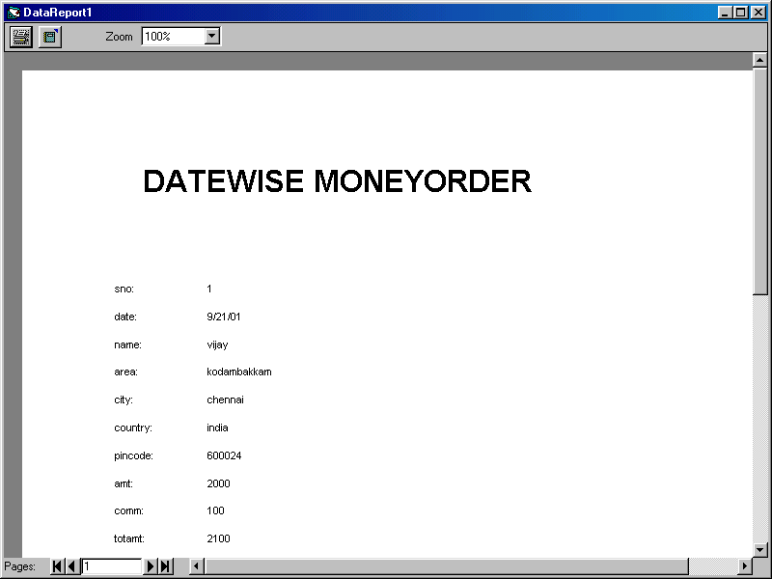

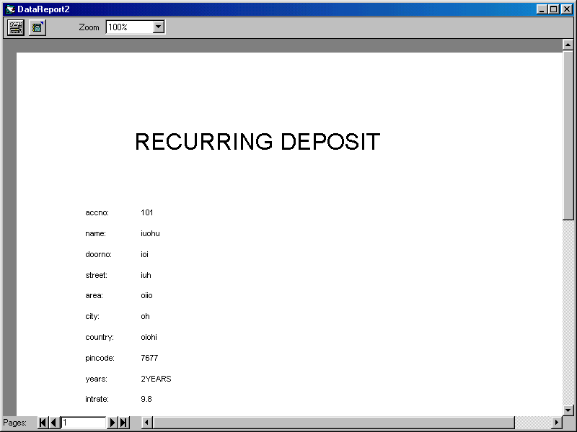

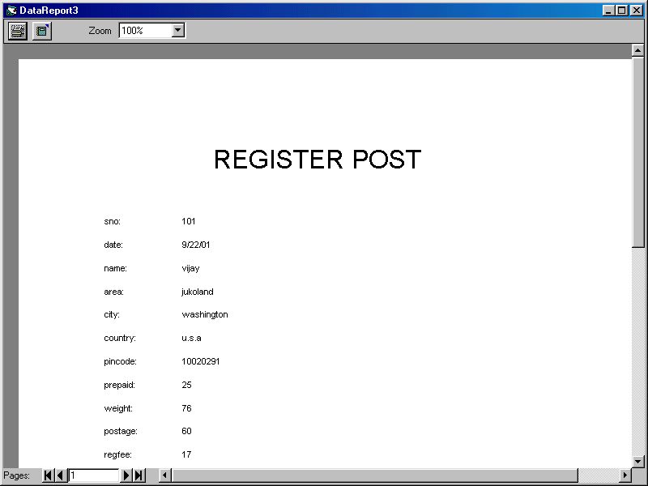

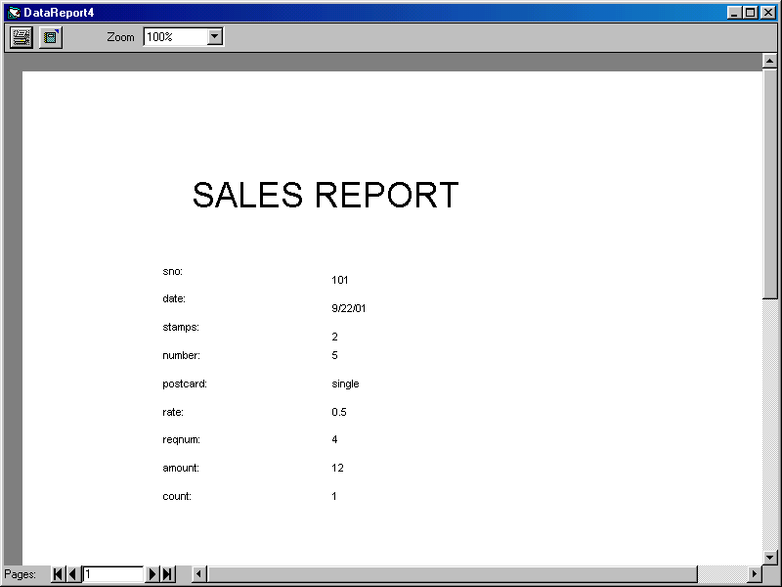

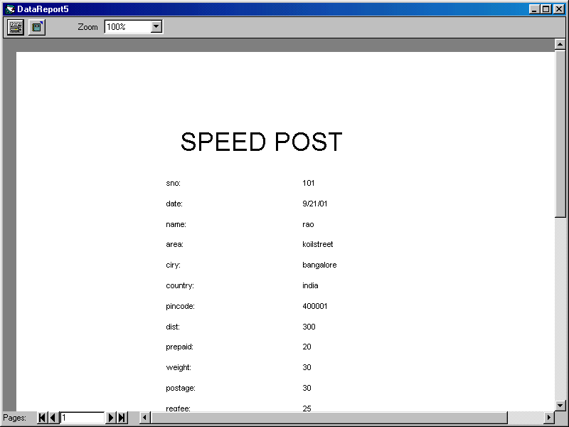

CONCLUSION

A computerized postal department system has been developed and the system was tested with sample data.

The system results in regular timely preparations of required outputs. In comparison with manual system the benefits under a computer system are considerable in the saving of man power working hours and Eiffel.

Provision for addition and deletion of customers is there in the system it is possible to view that proper filling system has been adopted to slate date for future. The entire project runs on windows environments.

The system can be used to make better management described at appropriate time. The user gets amount and timely information system.

SCOPE OF ENHANCEMENT

The system may be further updated or modified at will owing to its simple structure. If the organization willing the add a new module that would allow the vendor to the post office system. More over the developed system does not provide any kind of facility for making of the information.

BIBLIOGRAPHY

- MS – ACCESS ------- IVAN BAY ROSS

- VISUAL BASE VOLUME 1&11 ------ S.S.I PRESS

- DATA BASE MANAGEMENT SYSTEMS ----- KORTH

- SYSTEM ANALYSIS AND DESIGN ------ JAMES A.SENN

